DATABASE DESIGN

FINAL PROJECT REPORT

CAB MANAGEMENT SYSTEM

***INDEX***

1. ***INTRODUCTION***
2. ***REQUIREMENTS***
3. ***ENTITIES & RELATION***
4. ***ASSUMPTIONS***
5. ***FUNCTIONAL DEPENDENCIES***
6. ***FINAL RELATIONAL SCHEMA***
7. ***ER DIAGRAM***
8. ***SQL STATEMENTS***
9. ***TABLES AND THEIR VALUES***
10. ***SQL QUERIES***
11. ***CONCLUSION***
12. ***BIBLIOGRAPHY***

1.Introduction :

We have planned to produce a cab management system. In our system, the customer can book a cab as per their needs and location. In our system , we are providing our customers flexibility for choosing cab based on drop-of locations and journey. Also the customers who hold an membership-card generated by us would experience discounts on cab booking. We will see detailed description below:

2.Requirements:

1. Cab booking agency should have collection of cars.
2. Their would be car belonging to different categories and also belong to particular locations.
3. The customer can easily book a cab as per their needs.
4. Based on his location and cab category preferences, list of cabs available will be displayed.
5. In case the customer is a member of cab booking agency i.e they owe cab booking membership card then discount would be given on the total amount by booking the cab.

3.ENTITIES & RELATIONS

* Customer:

Customer will be the one who would be making a book of cab from cab booking agency. He/She can be member or non-member of the agency . Member of the agency would be given extra discount on booking price. Customer_info entity will store the details of the customer like their serial number, name , email id etc .

* Cab category:

The cab_info entity would be storing the various category of cabs available in the agency . It will have the attributes like car plate number, company name, model , rc number etc.

* Journey:

As we all know a traveller starts its journey with booking a cab..Hence journey entity owes its place in cab booking agency . Customer serial number, driver id number , start location, final location etc are stored in journey entity.

* Driver_Info:

Customers safety and satisfaction is also one of the goal of the agency. Also it is necessary and right of the customer to know with whom they are travelling . So Driver id no, name, license no, phone number , address etc attributes store the info of the driver.

* Medical_Info:

Along with knowing the driver’s info , their medical status is also a requirement for a safe journey. Medical_info entity is in alignment with the information required by storing the info of medical status of the driver assigned in attributes like height of driver, blood group , any illness etc.

* Cab management info:

Cab management info contains the info about the booking done by the customer. It contains the attributes like customer serial number, driver id number , car plate number , medical report number etc.

* Membership programme:

For enjoying the premium facilities given by the agency like remote area pick-ups , refreshments etc and also enjoying heavy discounts membership programme is built . Membership card is given to the members. Attributes like Type, Months_Duration , charges , discount % , insurance_amount etc store the info for membership card.

*RELATIONS:*

1. Customer Information to Cab information:

Every customer enter the details during the registration in cab agency . On the basis of the information the required cab is alloted for the journey. The info of various cab available in the agency is stored in cab information table .The relation name is ‘Rides’.

1. Cab information to driver information:

When the cab is alloted to a customer , a driver is also assigned with the cab for the journey. The info about the driver is stored in driver information table.The relation name is ‘Drives’.

1. Customer information to journey:

When a customer books a cab, he/she filles the required customer details which are stored in customer information table. The info about the pick up points and drop off ,amount ,driver allotment etc, i.e info about journey is stored in journey table. The relation name is ‘travels’.

1. Driver to Medical report:

As ensuring safe journey is an important part of cab booking agency. So for the allotment of the driver certain info about driver and their medical status is stored in Medical report table. The relation name is ‘Acquires’.

1. Customer to Membership:

If a customer is willing to be a member of cab booking agency and enjoy the privileges assosiated with the memebership , they have to enrol in membership program. Details of the members of the agency is stored in membership program table.The relation name is ‘Purchases’.

5.ASSUMPTIONS:

a) Each booking is associated with only one car reservation at a time.

b) Car available in the system should be present at some location.

c) Distance travelled is decided by the driver because he could take any route.

d) Fare for each kilometer travelled is Rs.20.

e) Car would only be booked only if car location and Customers' start location is same.

f) Each driver has fixed salary of Rs.6000 per month , additionaly he would get 10% of per ride as a commission.

6.FUNCTIONAL DEPENDENCIES:

*a) Customer_Info:*

Cus_Serial_Num **🡪** Cus_Name, Cus_Phone_No, Cus_Start_Loc, Cus_Final_Loc, Cus_Email, Membership_Type, Membership_StartTime, Membeship_ExpiryTime;

*b) Car_Info:*

Car_Plate_No **🡪** Car_Name, Model_No, Engine_Number, Insurance_No, Pollution_Check, No_of_Seats, Car_Loc;

*c) Medical_Report:*

Report_No **🡪** Driver_Height, Eyesight_Left, Eyesight_Right, Birth_Mark, Any_Illness;

*d) Driver_Info:*

Id_No **🡪**  Driver_Name,Driving_Lic_No,Phone_No , Adress, Gender, Age, Car_Plate_No;

*e) Journey:*

Cus_Serial_Num **🡪** Journey_Id, Cus_Serial_num, Driver_Id_No, Car_Plate_No, Cus_Start_Loc, Cus_Final_Loc, Distance_Travelled, Total_Fare;

*f) Membership_Program:*

Type **🡪** Months_Duration, Charges, Discount_Percent, Rides_free, Insurance_Amount;

7.FINAL RELATIONAL SCHEMA:

a) Customer Info:

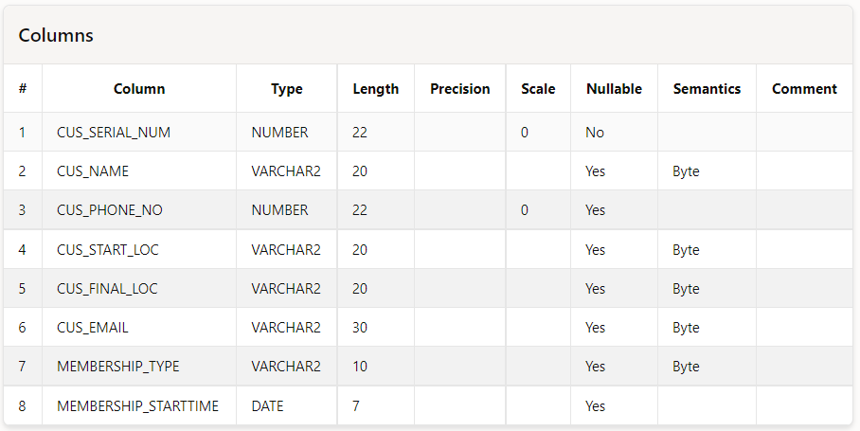

b) Car_Info:

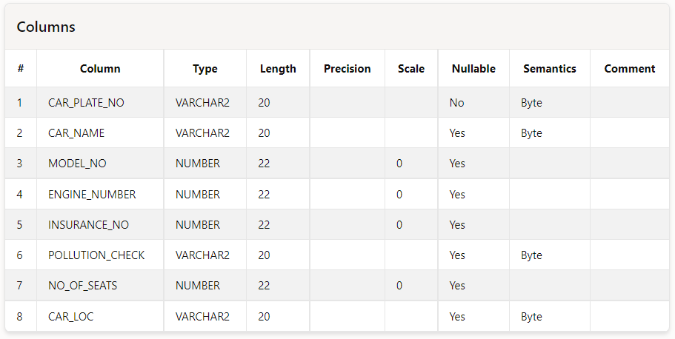

**c) Medical_Report:**

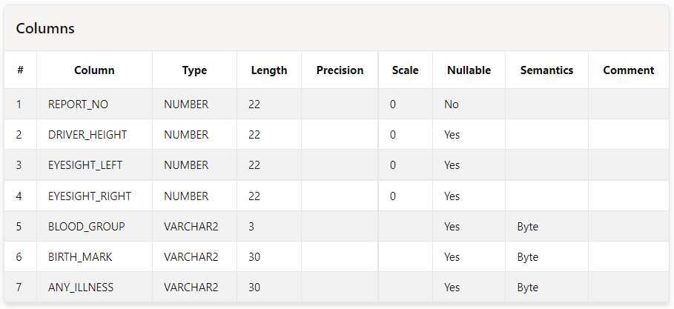

**d) Driver_Info:**

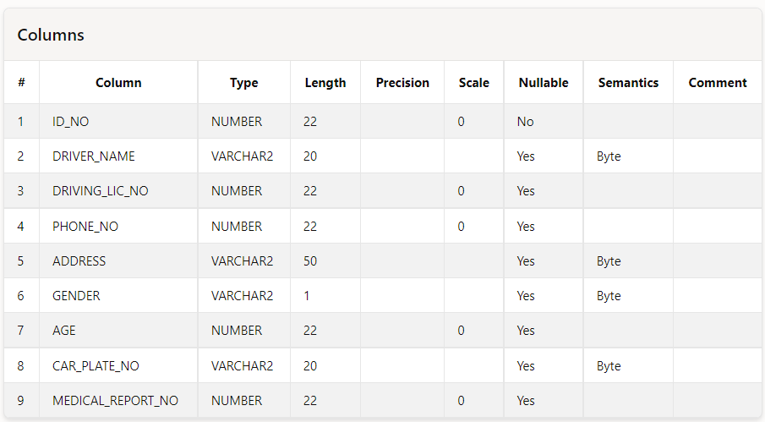

**e) Journey:**

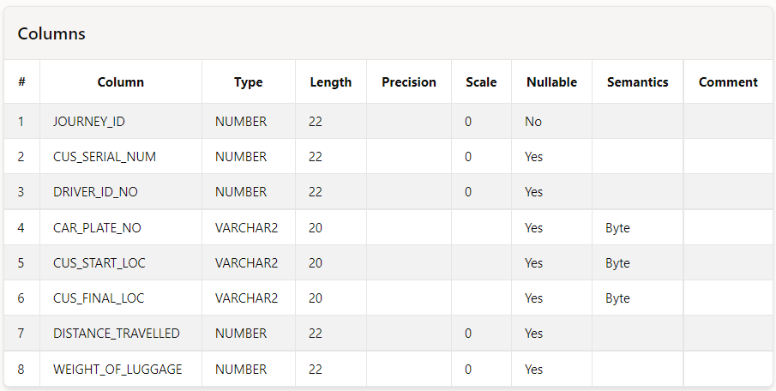

**f) Membership_program:**

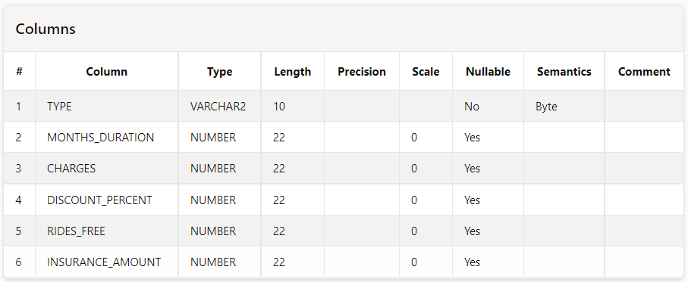

8. ER DIAGRAM:

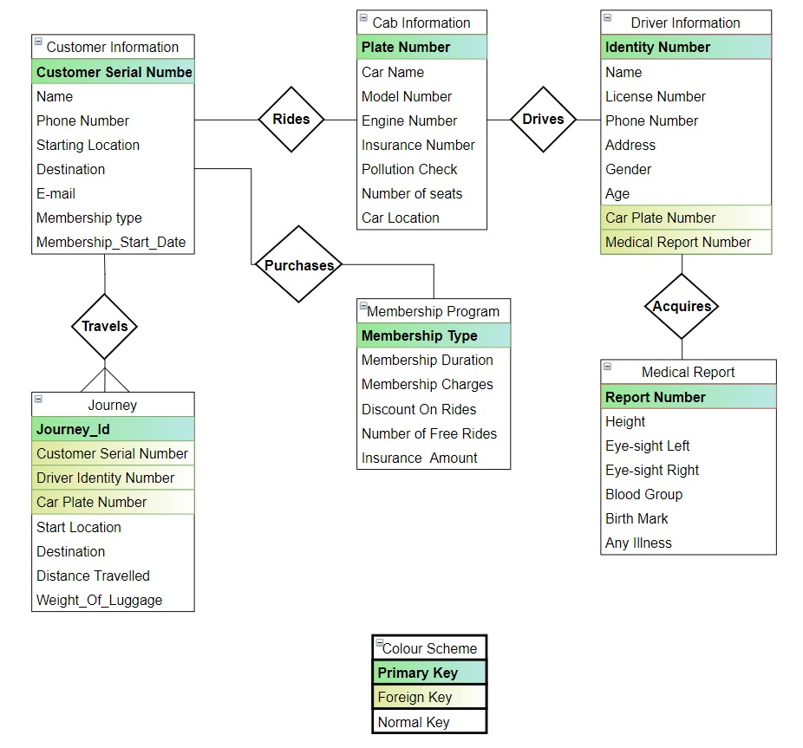

9. SQL STATEMETS:

9.1 CREATE STATEMTS:

a) Customer_Info:

create table Customer_Info

(Cus_Serial_Num int PRIMARY KEY,

Cus_Name varchar(20),

Cus_Phone_No int,

Cus_Start_Loc varchar(20),

Cus_Final_Loc varchar(20),

Cus_Email varchar(30),

Membership_type varchar(10),

Membership_StartTime Date

);

b) Car_Info:

create table Car_Info

(Car_Plate_No varchar(20) PRIMARY KEY,

Car_Name varchar(20),

Model_No int,Engine_Number int,

Insurance_No int,

Pollution_Check varchar(20),

No_of_Seats int,

Car_loc varchar(20)

);

c) Medical_Report:

create table Medical_Report

(Report_No int PRIMARY KEY,

Driver_Height int,

Eyesight_Left int,

Eyesight_Right int,

Blood_Group varchar(3),

Birth_Mark varchar(30),

Any_Illness varchar(30)

);

d) Driver_Info:

create table Driver_Info

(Id_No int PRIMARY KEY,

Driver_Name varchar(20),

Driving_Lic_No int,

Phone_No int,

Address varchar(50),

Gender varchar(1),

Age int,

Car_Plate_No varchar(20) ,

FOREIGN KEY (Car_Plate_No)

REFERENCES Car_Info(Car_Plate_No),

Medical_Report_No int,

FOREIGN KEY (Medical_Report_No)

REFERENCES Medical_Report(Report_No)

)

e)Journey:

create table Journey

(Journey_Id int Primary Key,

Cus_Serial_Num int,

FOREIGN KEY (Cus_Serial_Num)

REFERENCES Customer_Info(Cus_Serial_Num),

Driver_Id_No int,

FOREIGN KEY (Driver_Id_No)

REFERENCES Driver_Info(Id_No),

Car_Plate_No varchar(20),

FOREIGN KEY (Car_Plate_No)

REFERENCES Car_Info(Car_Plate_No),

Cus_Start_Loc varchar(20),

Cus_Final_Loc varchar(20),

Distance_Travelled int,

Weight_of_Luggage int

)

f) Cab_Management:

create table Cab_Management_Info

(Cus_Serial_Num int,

FOREIGN KEY (Cus_Serial_Num)

REFERENCES Customer_Info(Cus_Serial_Num),

Driver_Id_No int ,

FOREIGN KEY (Driver_Id_No)

REFERENCES Driver_Info(Id_No),

Car_Plate_No varchar(20) ,

FOREIGN KEY (Car_Plate_No)

REFERENCES Car_Info(Car_Plate_No),

Medical_Report_No int,

FOREIGN KEY (Medical_Report_No)

REFERENCES Medical_Report(Report_No)

)

g) Membership_Program:

create table Membership_Program

(Type varchar(10) Primary Key,

Months_Duration int,

Charges int,

Discount_Percent int,

Rides_free int,

Insurance_Amount int

);

9.2 INSERTION STATEMENTS:

a) Customer_Info:

insert all

into Customer_Info Values(1,'Rahul',9876543210,'Ludhiana','Chandigarh','rahul5@gmail.com','Bronze',TO_DATE('02.04.2018','DD.MM.YYYY'))

into Customer_Info Values(2,'Ramesh',9401423443,'Chandigarh','Ludhiana','ramesh401@gmail.com','Gold',TO_DATE('12.10.2020','DD.MM.YYYY'))

into Customer_Info Values(3,'Arjun',7873423510,'Patiala','Amritsar','arjun87@gmail.com','Bronze',TO_DATE('24.10.2021','DD.MM.YYYY'))

into Customer_Info Values(4,'Sanjay',7849495785,'Bathinda','Kapurthala','sanjay68@gmail.com','Gold',TO_DATE('09.01.2017','DD.MM.YYYY'))

into Customer_Info Values(5,'Rohan',9859333404,'Ludhiana','Jalandhar','rohan87@gmail.com','Bronze',TO_DATE('06.05.2019','DD.MM.YYYY'))

into Customer_Info Values(6,'Vansh',9173313745,'Chandigarh','Amritsar','vansh37@gmail.com','Silver',TO_DATE('03.08.2020','DD.MM.YYYY'))

into Customer_Info Values(7,'Rohan',7856608801,'Amritsar','Ludhiana','rohan61@gmail.com','Bronze',TO_DATE('12.07.2020','DD.MM.YYYY'))

into Customer_Info Values(8,'Arun',7804369305,'Mansa','Pathankot','arun04@gmail.com','Platinum',TO_DATE('29.10.2020','DD.MM.YYYY'))

into Customer_Info Values(9,'Jay',9074479401,'Sangrur','Mohali','jay07@gmail.com','Silver',TO_DATE('02.09.2018','DD.MM.YYYY'))

into Customer_Info Values(10,'Rajesh',9156651253,'Firozpur','Hoshiarpur','rajesh16@gmail.com','Gold',TO_DATE('27.10.2018','DD.MM.YYYY'))

select * from Dual;

b) Car_Info:

insert all

into Car_Info Values('PB01AY8438', 'Suzuki Swift', 2005, 1234763, 0000006357, 'YES', 4, 'Ludhiana')

into Car_Info Values('PB11CY1231', 'Tata Indica', 2004, 8285627, 0006483856, 'YES', 4, 'Chandigarh')

into Car_Info Values('PB21RR5343', 'Suzuki WagonR', 2009, 2678373, 0000383348, 'YES', 4, 'Patiala')

into Car_Info Values('PB07BC7742', 'Suzuki Swift', 2010, 3772637, 0000006301, 'NO', 4, 'Bathinda')

into Car_Info Values('PB13AD2562', 'Hero Splendor', 2015, 3727782, 0000827383, 'YES', 2, 'Ludhiana')

into Car_Info Values('PB23EF7544', 'Suzuki WagonR', 2013, 1282834, 0000123844, 'YES', 4, 'Chandigarh')

into Car_Info Values('PB17YZ7317', 'Toyota Qualis', 2005, 2348485, 0000763728, 'YES', 7, 'Amritsar')

into Car_Info Values('PB02SD4374', 'Bajaj Discover', 2009, 5434763, 0000234322, 'YES', 2, 'Mansa')

into Car_Info Values('PB09AF6256', 'Suzuki Swift', 2014, 3884746, 0000543261, 'YES', 4, 'Sangrur')

into Car_Info Values('PB16CY3275', 'Tata Indico', 2007, 8484484, 0000652453, 'YES', 4, 'Firozpur')

select * from Dual

c) Medical_Report:

insert all

into Medical_Report Values(0021, 176, 6, 6, 'O+', 'Mole on stomach', 'No')

into Medical_Report Values(0043, 165, 6, 5, 'B+', 'Scar under left eye', 'Diabetes')

into Medical_Report Values(0013, 180, 6, 6, 'A+', 'Dark Patch on back ', 'No')

into Medical_Report Values(0042, 182, 5, 6, 'AB+', 'Mole on right shoulder', 'Diabetes')

into Medical_Report Values(0056, 171, 6, 6, 'A+', 'Cut mark on left hand', 'No')

into Medical_Report Values(0045, 172, 4, 4, 'O+', 'Mole near nose', 'No')

into Medical_Report Values(0065, 169, 6, 6, 'O+', 'Scar under right eye', 'Low BP')

into Medical_Report Values(0076, 185, 6, 6, 'A-', 'Beauty mark on left arm', 'No')

into Medical_Report Values(0029, 175, 5, 6, 'AB+', 'right ear pierced', 'psoriasis')

into Medical_Report Values(0006, 176, 4, 6, 'O-', 'Beaty mark on face', 'No')

select * from Dual

d) Driver_Info:

insert all

into Driver_Info Values(7050, 'Rajesh', 9133709, 9873652636, 'H.No 10, St.No 9, Model Town, Ludhiana', 'M', 35, 'PB01AY8438', 0021)

into Driver_Info Values(4451, 'Ram', 2158642, 9873563903, 'H.No 210, St.No 1, Urban Estate, Chandigarh', 'M', 32, 'PB11CY1231', 0043)

into Driver_Info Values(7516, 'Amar', 7066179, 7876482548, 'H.No 235, St.No 10, Sector 2, Patiala', 'M', 25, 'PB21RR5343', 0013)

into Driver_Info Values(8896, 'Vijender', 1285807, 7863782785, 'H.No 1453, St.No 2, Yadvindra Enclave, Bathinda', 'M', 40, 'PB07BC7742', 0042)

into Driver_Info Values(4124, 'Preeti', 3237695, 9973863595, 'H.No 130, St.No 6, Anand Nagar, Ludhiana', 'F', 27, 'PB13AD2562', 0056)

into Driver_Info Values(1207, 'Komal', 5168912, 7893957483, 'H.No 435, St.No 5, Doctor Colony, Chandigarh', 'F', 29, 'PB23EF7544', 0045)

into Driver_Info Values(4011, 'Rohan', 7214513, 7849296537, 'H.No 546, St.No 9, Prem Nagar, Amritsar', 'M', 25, 'PB17YZ7317', 0065)

into Driver_Info Values(3906, 'Akash', 6619700, 98888647362, 'H.No 754, St.No 7, Ekata Vihar, Mansa', 'M', 38, 'PB02SD4374', 0076)

into Driver_Info Values(1461, 'Kunal', 5727592, 9946273839, 'H.No 654, St.No 3, SST Nagar, Sangrur', 'M', 35, 'PB09AF6256', 0029)

into Driver_Info Values(9957, 'Gourav', 5353652, 7883673773, 'H.No 23, St.No 2, Phase 2, Firozpur', 'M', 31, 'PB16CY3275', 0006)

select * from Dual

e) Journey:

insert all

into Journey Values(1001,1, 7050, 'PB01AY8438', 'Ludhiana','Chandigarh',100,20)

into Journey Values(1002,2, 4451, 'PB11CY1231', 'Chandigarh','Ludhiana',100,42)

into Journey Values(1003,3, 7516, 'PB21RR5343', 'Patiala','Amritsar',234,46)

into Journey Values(1004,4, 8896, 'PB07BC7742', 'Bathinda','Kapurthala',180,36)

into Journey Values(1005,5, 4124, 'PB13AD2562', 'Ludhiana','Jalandhar',62,12)

into Journey Values(1006,6, 1207, 'PB23EF7544', 'Chandigarh','Amritsar',227,45)

into Journey Values(1007,7, 4011, 'PB17YZ7317', 'Amritsar','Ludhiana',141,28)

into Journey Values(1008,8, 3906, 'PB02SD4374', 'Mansa','Pathankot',293,58)

into Journey Values(1009,9, 1461, 'PB09AF6256', 'Sangrur','Mohali',124,50)

into Journey Values(1010,10, 9957, 'PB16CY3275', 'Firozpur','Hoshiarpur',195,39)

select * from Dual

f) Cab_Management:

insert all

into Cab_Management_Info Values(1, 7050, 'PB01AY8438', 0021)

into Cab_Management_Info Values(2, 4451, 'PB11CY1231', 0043)

into Cab_Management_Info Values(3, 7516, 'PB21RR5343', 0013)

into Cab_Management_Info Values(4, 8896, 'PB07BC7742', 0042)

into Cab_Management_Info Values(5, 4124, 'PB13AD2562', 0056)

into Cab_Management_Info Values(6, 1207, 'PB23EF7544', 0045)

into Cab_Management_Info Values(7, 4011, 'PB17YZ7317', 0065)

into Cab_Management_Info Values(8, 3906, 'PB02SD4374', 0076)

into Cab_Management_Info Values(9, 1461, 'PB09AF6256', 0029)

into Cab_Management_Info Values(10, 9957, 'PB16CY3275', 0006)

select * from Dual

g) Membership_Program:

Insert all

into Membership_Program Values('Bronze',1,500,3,0,0)

into Membership_Program Values('Silver',3,1200,5,0,0)

into Membership_Program Values('Gold',6,2500,6,1,0)

into Membership_Program Values('Platinum',12,7000,6,5,5000)

Select * from Dual;

10. Tables and their Values:

a) Customer_Info:

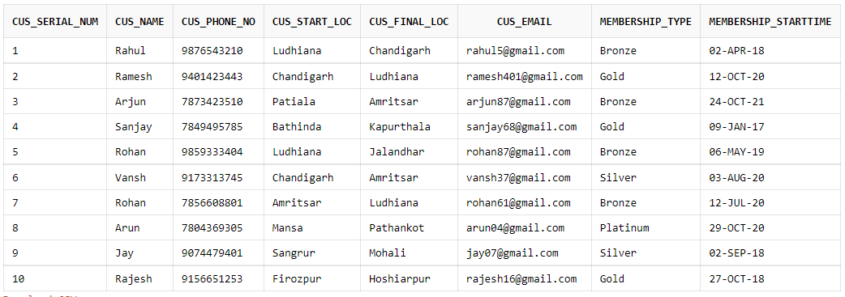

b) Car_Info:

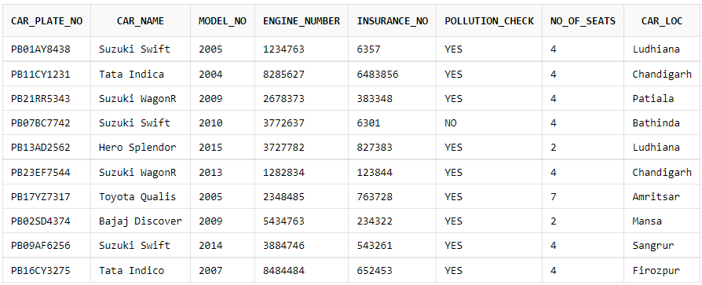

c)Driver_Info:

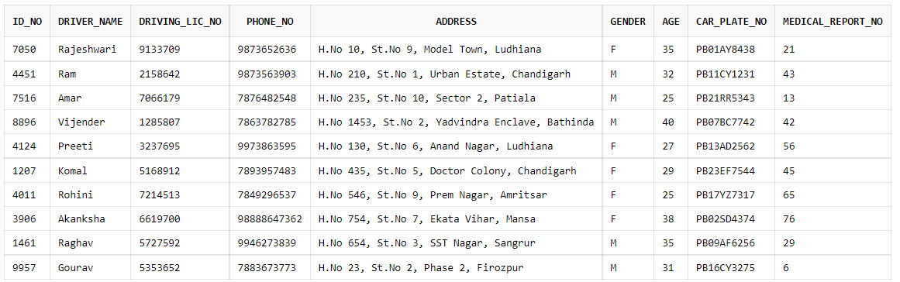

d)Medical_Report:

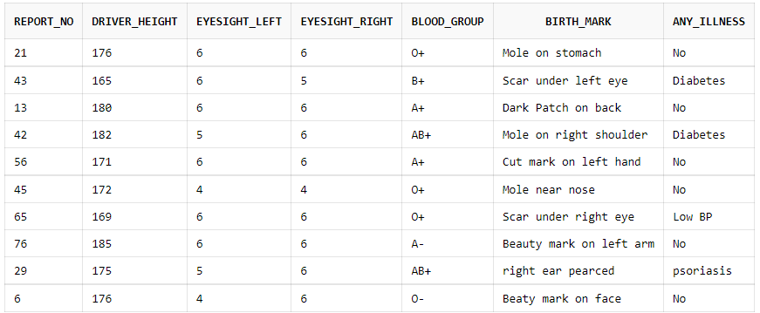

e) Journey:

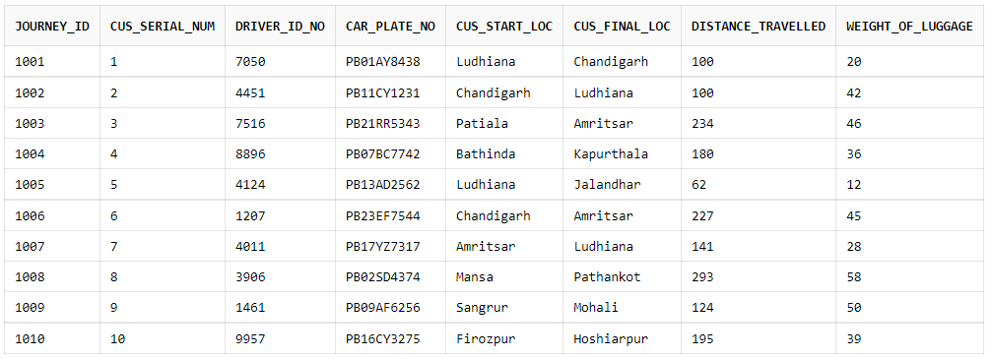

f) Cab_Management_Program:

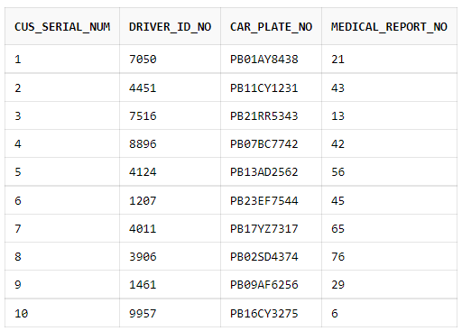

g) Membership_program:

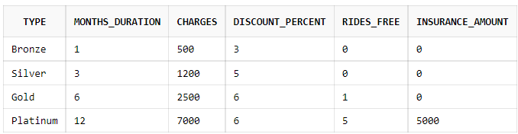

11. SQL QUERIES:

A) Select Cus_Serial_Num, Distance_Travelled, Weight_of_Luggage, Distance_Travelled*20) +(Weight_of_Luggage*2) "Total_Fare" from Journey;

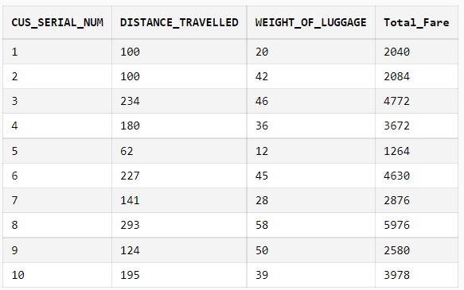

B) select Customer_Info.Cus_Serial_Num, Customer_Info.Membership_StartTime "Membership_Start_Date" ,add_months (Customer_Info.Membership_StartTime, Membership_Program.Months_Duration) "Membership_Expiry_Date"from Customer_Info,Membership_Program where (Customer_Info.Membership_type =Membership_Program.Type);

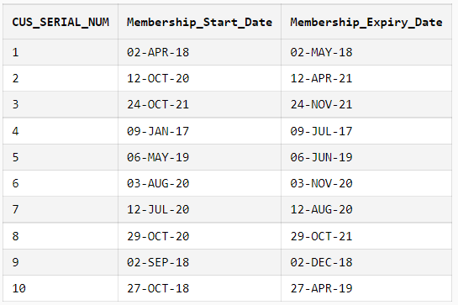

C) select Cus_Serial_Num, Cus_Name,Cus_Start_Loc, Car_Plate_No, Car_Name, No_of_Seats from Customer_Info right outer join Car_Info on Car_Info.Car_Loc=Customer_Info.Cus_Start_Loc;

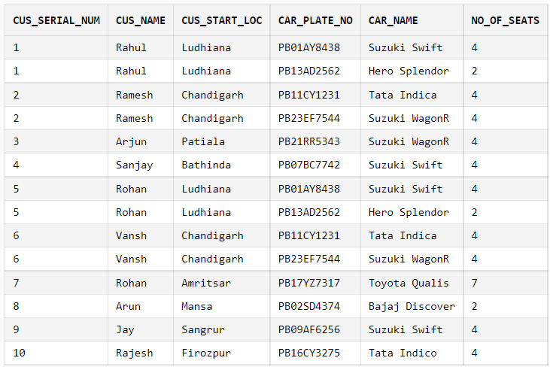

D) select No_of_Seats,Count(No_of_Seats) "No_of_Cars" from Car_Info group by No_of_Seats;

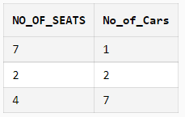

E) select Car_Loc, count(Car_Plate_No) from Car_Info group by Car_Loc;

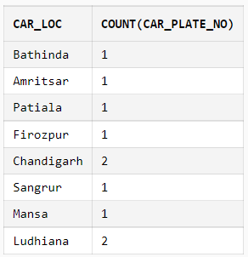

F) select CUS_SERIAL_NUM,CUS_SERIAL_NUM, CUS_PHONE_NO, MEMBERSHIP_TYPE, MONTHS_DURATION,CHARGES,INSURANCE_AMOUNT from Membership_program left outer join Customer_Info on Customer_Info.Membership_Type=Membership_program.Type;

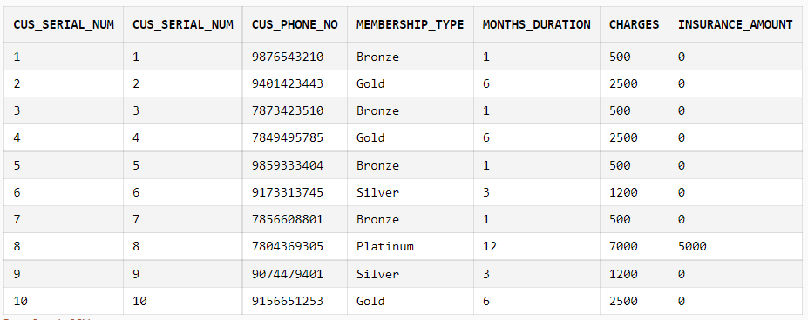

G) select Driver_Info.Driver_Name, Medical_Report.Any_Illness from Driver_Info join Medical_Report on Driver_Info.Medical_Report_No = Medical_Report.Report_No where Medical_Report.Any_Illness != 'No';

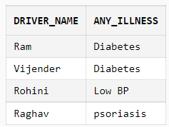

H) select * from Car_info where car_loc ='Ludhiana';

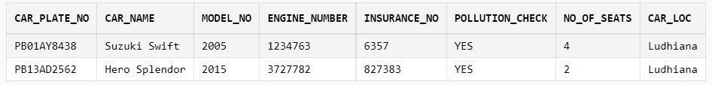

I) select Medical_Report.Report_No, Driver_Info.Driver_Name, Driver_Info.Phone_No, Medical_Report.Driver_Height, Medical_Report.Eyesight_Left, Medical_Report.Eyesight_Right, Medical_Report.Blood_Group, Medical_Report.Any_Illness from Driver_Info join Medical_Report on Driver_Info.Medical_Report_No = Medical_Report.Report_No;

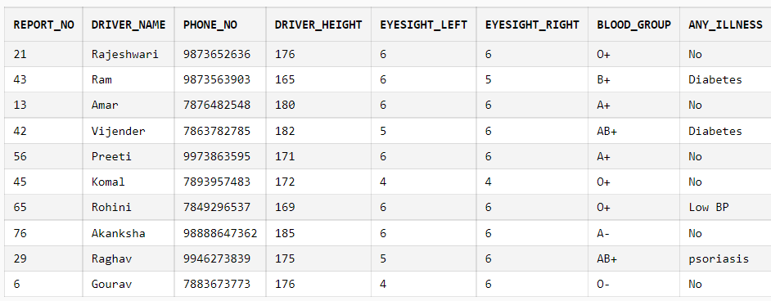

J) select Driver_name from Driver_info where Gender='M';

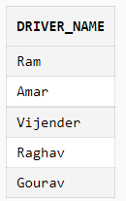

K) select Driver_Info.Driver_Name, Driver_Info.Driving_Lic_No, Car_Info.Car_Name, Car_Info.Car_Plate_No , Car_Info.Pollution_Check from Driver_Info join Car_Info on Driver_Info.Car_Plate_No = Car_Info.Car_Plate_No;

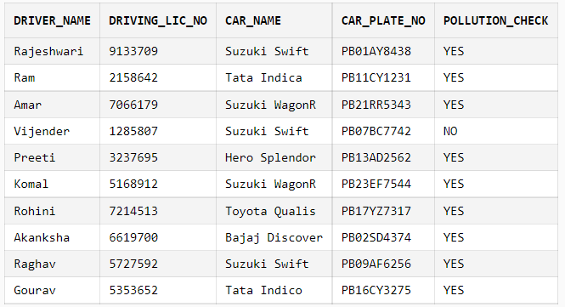

**12. CONCLUSION:**

During the course of this project, we learnt a lot of the work and best practices that go into creating a database, the rules to construct a good ER diagram, How to come up with relational schema mapping from the ER diagram, deriving the functional dependencies. We learnt on how to design a system from Database perspective and how to efficiently store and manipulate data.